Topical Medication Administration Chart

Resident’s name: | DoB: | Allergies:
Name of topical preparation: |  | Completed by: | Checked by:
Site of application: |  | Storage:
Frequency of application: | Reason for applying:
Start date: | End date:

28 Day Application Chart |  |  |  |  |  |  |  |  |  | FRONT
Date | Time | Signature | Time | Signature | Time | Signature |  | Time | Signature
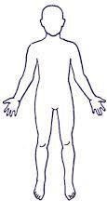
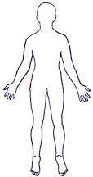
BACK
Date Opened: |  |  |  |  |  |  | Expiry date after opening:

